|  |
| --- |
| Creating Web Application |
| COS10011  Semester 2, 2021 |
|  |
|  |
|  |

|  |  |
| --- | --- |
| Member Name | Member ID |
| Khalid Yaseen Baig | 102763240 |

|  |
| --- |
|  |

**Table of Contents**

**Assignment 1**

# Introduction **1**

## Scope of the website 1

## Intended audience 1

# Website Design & Structure2

## Website Layout Mock ups 2

## Website Structure 4

# End Product………………………………………………………………………..5

## Actual User Interface………………………………………………………………………………5

## Enhancements (if any)…………………………………………………………………………13

**Assignment 2**

1. Description 15

# 2. End Product………………………………………………………………………..25

## 2.1 Actual User Interface………………………………………………………………………………15

## 2.2 Enhancements (if any)…………………………………………………………………………28

**Assignment 1**

1. **Introduction**

*[Brief introduction to the website: background and objectives]*

* 1. **Scope of the website**

This website is designed to be a one stop Accessories shopping spot for all the needs of millennial men, ranging from watches to even Rings. Our user interface is designed to feel very Modern & Aesthetic to attract our target audience. The visitors will be very delighted to Shop in our website thanks to our well designed and well linked website, so they won’t face any hurdles navigating through different pages. We also feature an enquiry form which enables the consumer to contact us easily if they want to enquire anything about the products mentioned in our website.

I would like to credit following websites for inspiration:

* <https://classymencollection.com/>
* <https://www.mvmt.com/>
* <https://theme823-mens-fashion.myshopify.com/>
  1. **Intended audience**

Our intended/targeted audience as our brand name suggests are the millennial Men of today’s world, who are basically the men under the age of 30. Our website is designed to cater to all their needs and wants from all price ranges and styles.

1. **Webpage Design and Structure**
   1. **Website Layout Mock ups**

*[Provide Wireframe/sketch of the website. You may use the available online tools such as* [*https://moqups.com/*](https://moqups.com/) *]*

***Index Page***

F Nav

Logo

Article

Aside

Section

vFooter

***Product & all other pages***

Nav

.Logo

.Section

.Footer

* 1. **Website Structure**

*[Provide hierarchical structure of the website]*

**Index**

**Acknowledgement**

**Enhancement**

**Profile**

**Disclaimer**

**Enquiry**

**Shop**

**Watches**

**Sunglasses**

**Backpacks**

**Shoes**

**Others**

1. **End Product**
   1. **Actual User Interface**

*[Provide screenshots of the websites. Justify and explain the design used based on the webpage design principles. Do some reading online for design principle guidelines]*

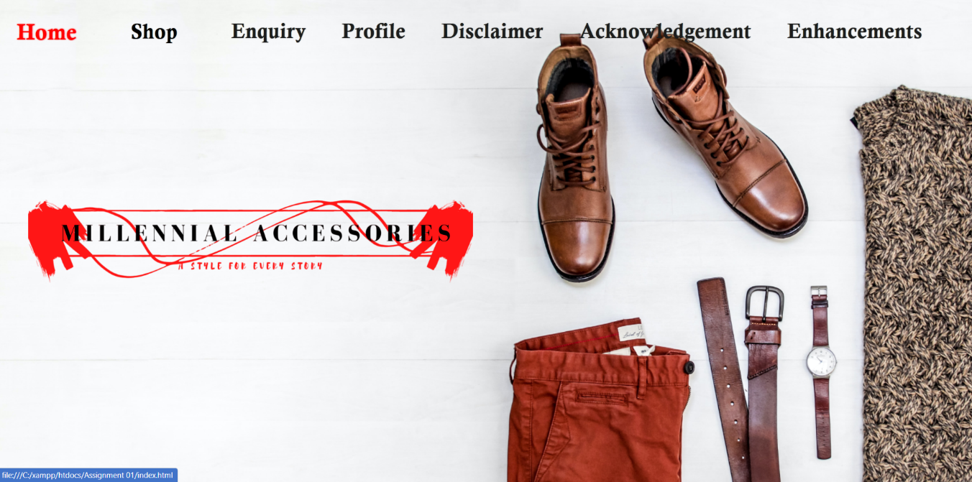

**Index page <header> & <nav>**

**

***Index Page <article> & <aside>***

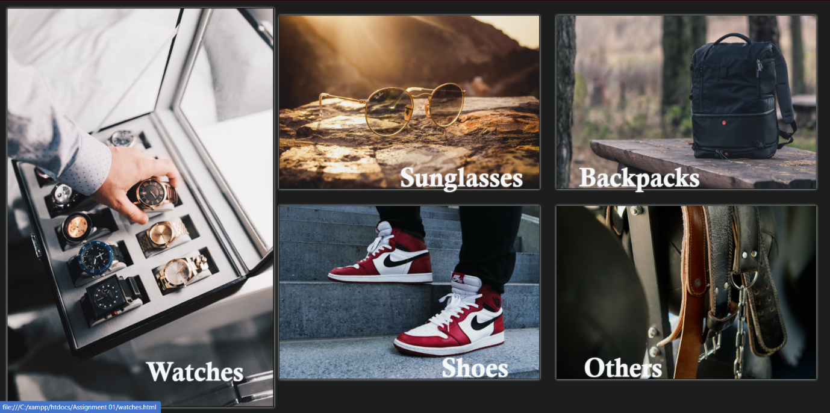

***Index Page <section> , an image gallery of products which also acts as a link to those pages.***

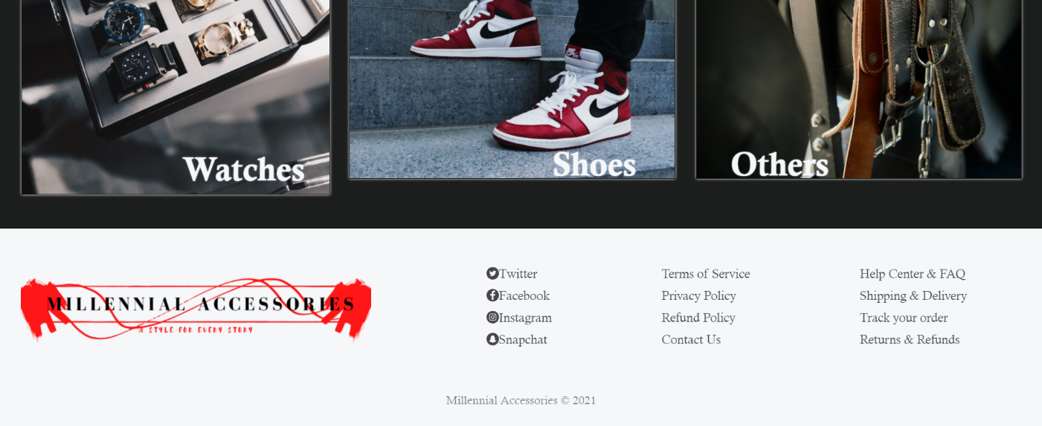

***<footer> across the website***

**

***Example of product page <header> & <nav>***

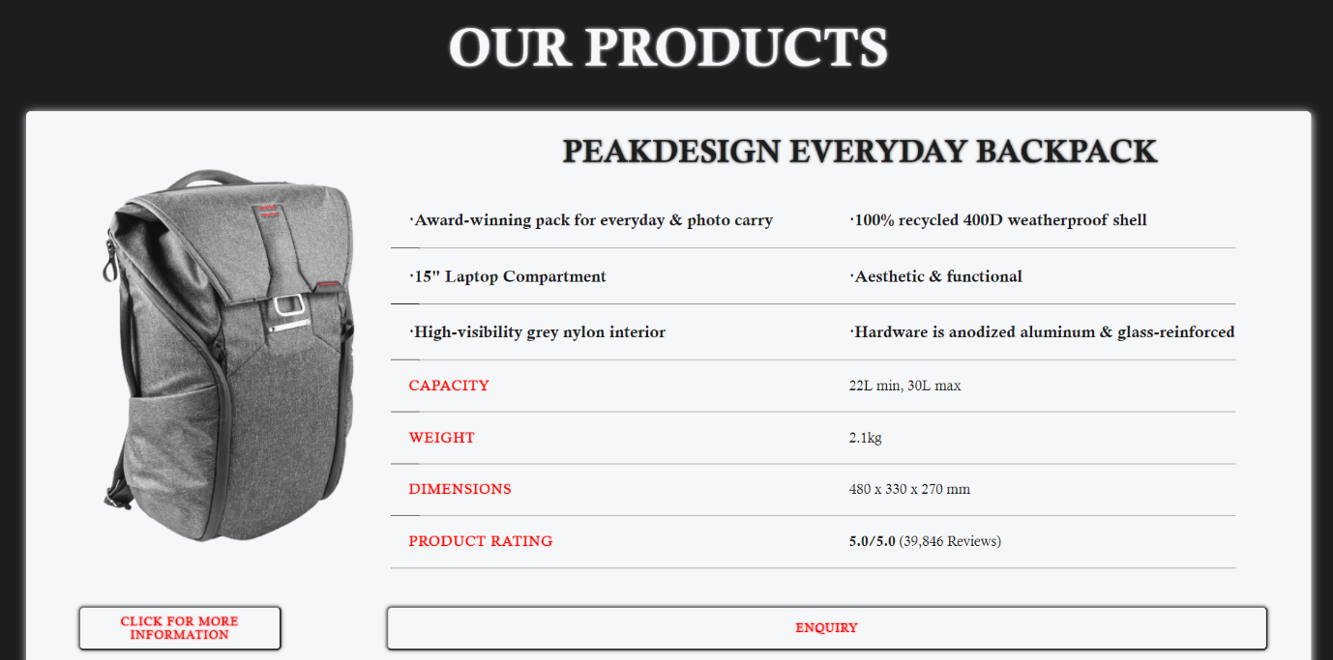

***Example of Product page <section> lisitng products.***

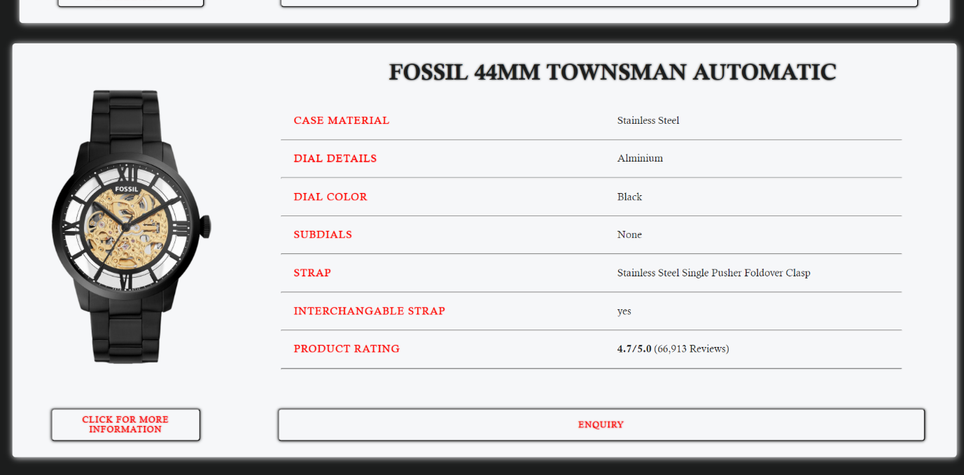

***Example of Product page <section> lisitng products***

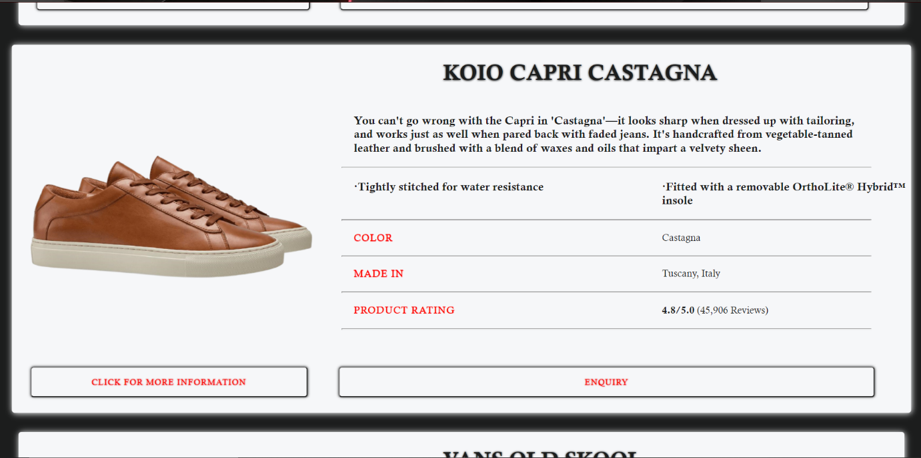

***Example of Product page <section> lisitng products***

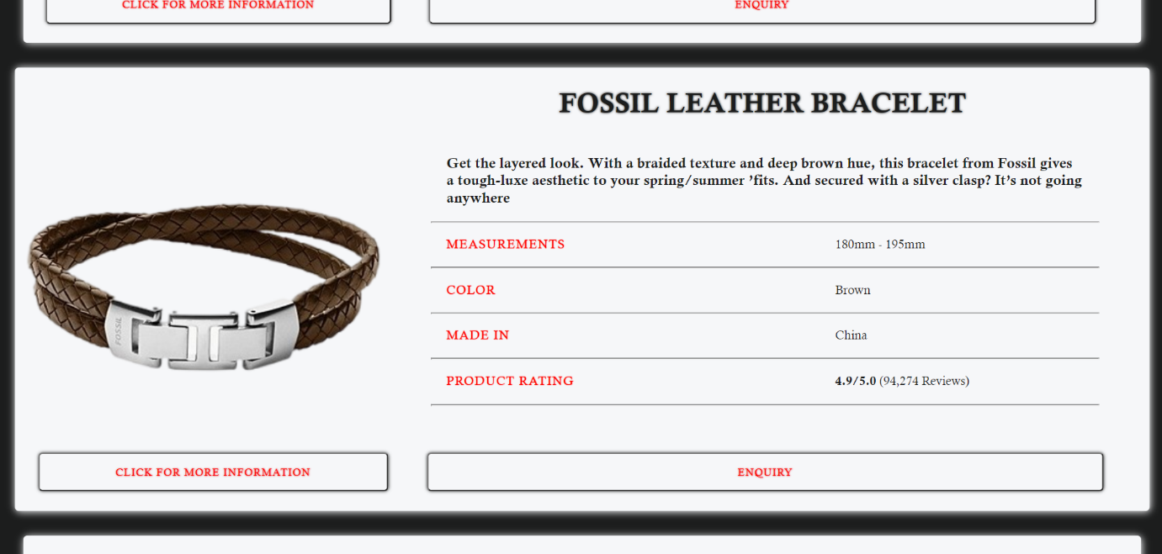

***Example of Product page <section> lisitng products***

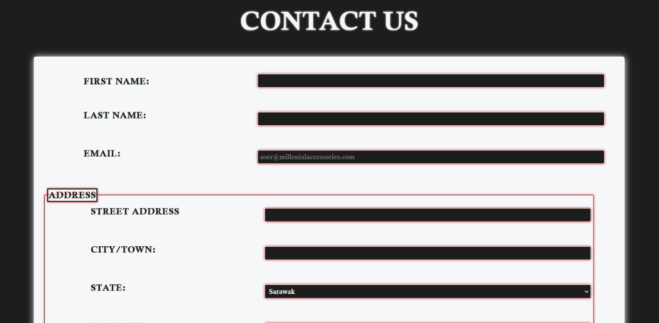

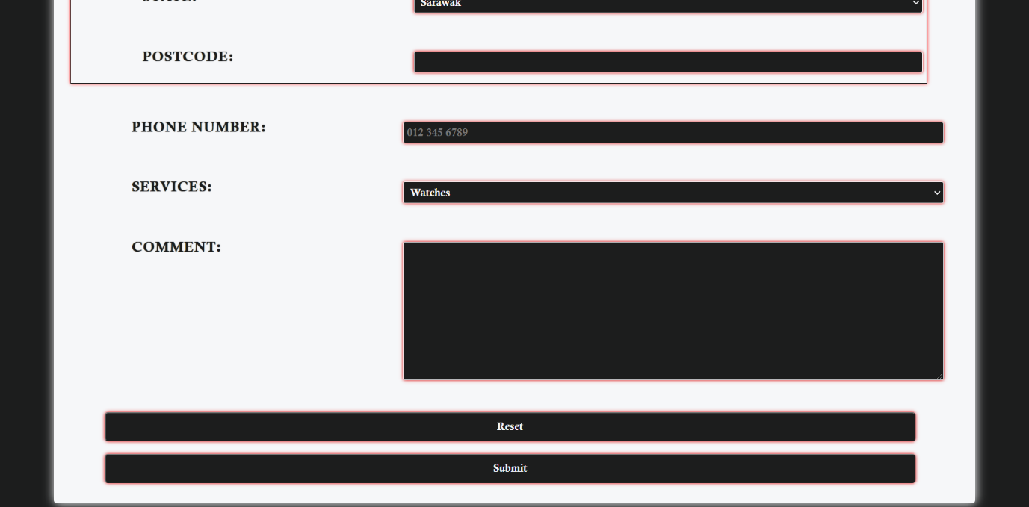

***Enquiry Page <form>***

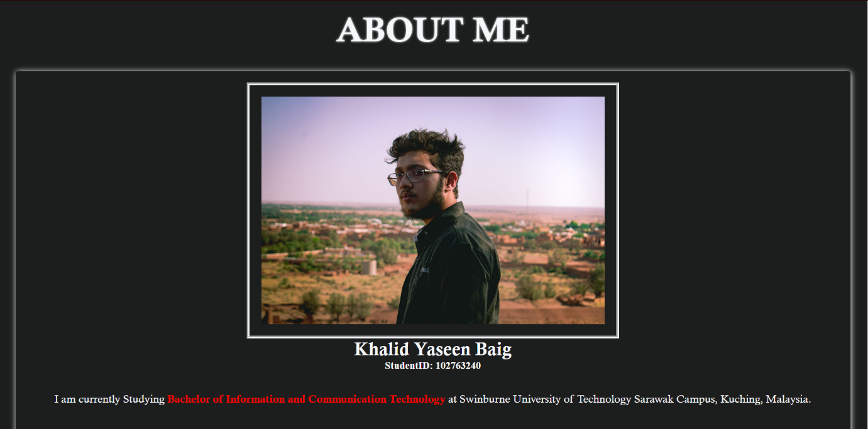

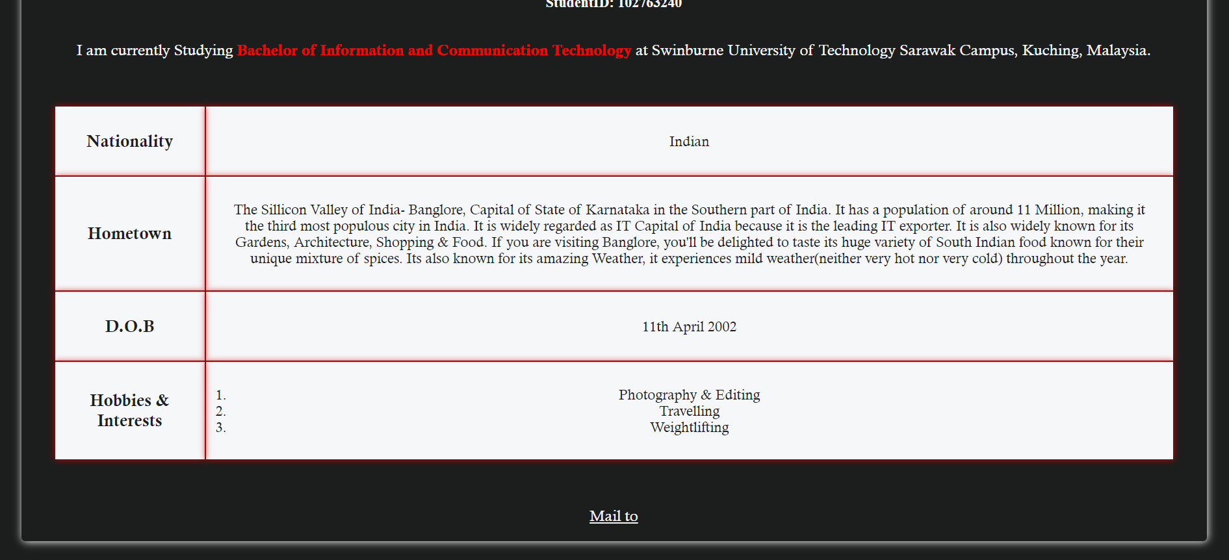

***Profile Page <Section> including <table>***

* 1. **Enhancements (if any)**

*[Describe the enhancements if any]*

# **1.linear-gradient**

* The linear-gradient() CSS function creates an image consisting of a progressive transition between two or more colors along a straight line. Its result is an object of the gradient data type, which is a special kind of image.
* CSS Code:{ background: linear-gradient(rgba(0,0,0,0.3),rgba(255,255,255,0.8),rgba(0,0,0,0.3));}
* [Source](https://developer.mozilla.org/en-US/docs/Web/CSS/gradient/linear-gradient()): <https://developer.mozilla.org/enUS/docs/Web/CSS/gradient/linear-gradient()>
* Enhancement is applied in the dropdown menu.

# **2.Absolute Positioning Inside Relative Positioning**

* A page element with relative positioning gives you the control to absolutely position children elements inside of it.
* CSS Code:{position:absolute; top:0; left:0;}
* [Source](https://css-tricks.com/absolute-positioning-inside-relative-positioning/): <https://css-tricks.com/absolute-positioning-inside-relative-positioning/>
* Enhancement is applied throughout the assignments, specifically for positioning the images and svg in index page

# **3.CSS transform Property**

* The transform property applies a 2D or 3D transformation to an element. This property allows you to rotate, scale, move, skew, etc., elements.
* CSS Code: {transform: scaleY(1.5)};
* [Source](https://www.w3schools.com/cssref/css3_pr_transform.asp): <https://www.w3schools.com/cssref/css3_pr_transform.asp>
* Enhancement is applied throughout the assignments, specifically for scaling properties while hover or transforming the properties to Uppercase.

# **.CSS transitions**

* CSS transitions provide a way to control animation speed when changing CSS properties. Instead of having property changes take effect immediately, you can cause the changes in a property to take place over a period of time
* CSS Code: { transition: all 0.7s ease; }
* [Source](https://developer.mozilla.org/en-US/docs/Web/CSS/CSS_Transitions/Using_CSS_transitions): <https://developer.mozilla.org/enUS/docs/Web/CSS/CSS_Transitions/Using_CSS_transitions>
* Enhancement is applied for the whole website by pplying it thru "*" at start of CSS file

# **CSS background-attachment Property**

* The background-attachment property sets whether a background image scrolls with the rest of the page, or is fixed.
* CSS Code:{background-image: url("./property.img"); background-repeat: no-repeat; background-attachment: fixed;}
* [Source](https://www.w3schools.com/cssref/pr_background-attachment.asp): <https://www.w3schools.com/cssref/pr_background-attachment.asp>
* Enhancement is applied throughout the assignments, specifically for the backdrops in all pages

# **Box-shadow Property**

* The box-shadow CSS property adds shadow effects around an element's frame. You can set multiple effects separated by commas. A box shadow is described by X and Y offsets relative to the element, blur and spread radius, and color.
* CSS Code: {box-shadow: 10px 5px 5px red;}
* [Source](https://developer.mozilla.org/en-US/docs/Web/CSS/box-shadow): <https://developer.mozilla.org/en-US/docs/Web/CSS/box-shadow>
* Enhancement is applied throughout the assignments as you can see in all the boxes.

**Assignment 2**

1. **Description**

Javascript is implemented in this website mainly for enabling the transfer of data between and within pages, storing dropdown menus in an array and Validating the HTML form in order to ensure none of the required field are left empty and correct format is being used in order to fill the form along with some enhancement for the website.

The code used for enabling transfer of data between pages is as follows:

function storeitem(product_id) {

sessionStorage.setItem("product_id", product_id);

window.location.replace("enquiry.html");

}

function displayitem() {

document.getElementById("subject").value = "RE: Enquiry on " + sessionStorage.getItem("product_id");

document.getElementById("product").value = sessionStorage.getItem("product_id");

}

function initalise() {

var formElement = document.getElementById("form");

displayitem();

}

window.onload = initalise;

The code used for enabling transfer of data within page is as follows:

function validateForm() {

var product = document.getElementById("product").value;

sessionStorage.product = product;

return result;

}

function storeProduct(productName) {

var options = ["Tag Heuer Carrera Porsche Chronograph Special Edition", "Diesel Mr. Daddy 2.0 chronograph black", "Bulgari Octo LOriginale Watch", "Casio G-Shock MRGB2000R-1A", "Fossil 44mm Townsman Automatic", "Ray-Ban Aviator Classic", "Tomahawk SeaPorts", "Ray-Ban Round Double Bridge", "Tomford arnaud polarized", "Randolph Aviator(Military)", "Peakdesign everyday Backpack", "Solgaard lifepack endeavor", "Bellroy Transit Backpack", "Matador SEG42 Travel Pack", "Woody Backpack (French)", "Nike Air Jordan 1 Mid", "Adidas iconic superstar", "Koio capri castagna", "vans old skool", "Reiss leather bay", "Maximum Henry classic belt", "Bellroy hide & seek wallet", "Doice & Gabbana Panama-style hat", "Fossil Leather bracelet", "Unique Tungsten Ring"];

options.forEach(array);

function array(value) {

if (value == productName) {

sessionStorage.productIndex = options.indexOf(value);

}

}

}

function storeSub() {

document.getElementById("product").selectedIndex = sessionStorage.productIndex;

var product = document.getElementById("product").value;

sessionStorage.subject = product;

document.getElementById("subject").value = "RE: Enquiry on " + sessionStorage.subject;

}

function productlist1() {

var select = document.getElementById("product");

var options = ["Tag Heuer Carrera Porsche Chronograph Special Edition", "Diesel Mr. Daddy 2.0 chronograph black", "Bulgari Octo LOriginale Watch", "Casio G-Shock MRGB2000R-1A", "Fossil 44mm Townsman Automatic", "Ray-Ban Aviator Classic", "Tomahawk SeaPorts", "Ray-Ban Round Double Bridge", "Tomford arnaud polarized", "Randolph Aviator(Military)", "Peakdesign everyday Backpack", "Solgaard lifepack endeavor", "Bellroy Transit Backpack", "Matador SEG42 Travel Pack", "Woody Backpack (French)", "Nike Air Jordan 1 Mid", "Adidas iconic superstar", "Koio capri castagna", "vans old skool", "Reiss leather bay", "Maximum Henry classic belt", "Bellroy hide & seek wallet", "Doice & Gabbana Panama-style hat", "Fossil Leather bracelet", "Unique Tungsten Ring"];

for (var i = 0; i < options.length; i++) {

var opt = options[i];

var el = document.createElement("option");

el.textContent = opt;

el.value = opt;

select.appendChild(el);

}

}

function change() {

var product = document.getElementById("product").value;

sessionStorage.product = product;

document.getElementById("subject").value = "RE: Enquiry on " + sessionStorage.product;

}

The code used for validating the HTML form is as follows:

function initalise() {

var formElement = document.getElementById("form");

formElement.onsubmit = validate;

}

window.onload = initalise;

var getErrorMsg = "";

function validate(){

"use strict";

var everythingOkay = false;

getErrorMsg = "";

var fnameOkay = fnameCheck();

var lnameOkay = lnameCheck();

var emailOkay = emailCheck();

var numOkay = numCheck();

var streetOkay = streetCheck();

var cityOkay = cityCheck();

var stateOkay = stateSelect();

var pcodeOkay = pcodeCheck();

var productOkay = productSelect();

var descriptionOkay = descriptionCheck();

if (fnameOkay && lnameOkay && emailOkay && numOkay && streetOkay && cityOkay && stateOkay && pcodeOkay && productOkay && descriptionOkay) {

everythingOkay = true;

}

else{

alert(getErrorMsg);

getErrorMsg = "";

everythingOkay = false;

}

return everythingOkay;

}

function fnameCheck(){

var name = document.getElementById("fname").value;

var pattern = /^[a-zA-Z ]+$/

var fnameOkay = true;

if ((name.length == 0)){

getErrorMsg = getErrorMsg + "Your First Name cannot be blank\n"

fnameOkay = false;

}

else{

if (!pattern.test(name)){

getErrorMsg = getErrorMsg + "Your First name should only contain characters\n"

fnameOkay = false;

}

}

return fnameOkay;

}

function lnameCheck(){

var name = document.getElementById("lname").value;

var pattern = /^[a-zA-Z ]+$/

var lnameOkay = true;

if ((name.length == 0)){

getErrorMsg = getErrorMsg + "Your Last Name cannot be blank\n"

lnameOkay = false;

}

else{

if (!pattern.test(name)){

getErrorMsg = getErrorMsg + "Your Last name should only contain characters\n"

lnameOkay = false;

}

}

return lnameOkay;

}

function emailCheck(){

var email = document.getElementById("email").value;

var result = true;

var pattern = /[a-zA-Z0-9._%+-]+@[a-zA-Z0-9.-]+\.[a-za-zA-Z0-9.-]{1,4}$/;

if ((email.length == 0)){

getErrorMsg = getErrorMsg + "Your Email cannot be blank\n"

result = false;

}

else{

if (!pattern.test(email)){

getErrorMsg = getErrorMsg + "Enter a Valid Email Address\n"

result = false;

}

}

return result;

}

function numCheck() {

var name = document.getElementById("number").value;

var pattern = /^[#.0-9,-]+$/

var numOkay = true;

if ((name.length == 0)){

getErrorMsg = getErrorMsg + "Phone Number cannot be blank\n"

numOkay = false;

}

else{

if (!pattern.test(name)){

getErrorMsg = getErrorMsg + "Enter a valid Phone Number\n"

numOkay = false;

}

}

return numOkay;

}

function streetCheck(){

var name = document.getElementById("street").value;

var pattern = /^[#.0-9a-zA-Z\s,-]+$/

var streetOkay = true;

if ((name.length == 0)){

getErrorMsg = getErrorMsg + "Street Address cannot be blank\n"

streetOkay = false;

}

else{

if (!pattern.test(name)){

getErrorMsg = getErrorMsg + " Enter a vlid Street Address\n"

streetOkay = false;

}

}

return streetOkay;

}

function cityCheck(){

var name = document.getElementById("city").value;

var pattern = /^[#.0-9a-zA-Z\s,-]+$/

var cityOkay = true;

if ((name.length == 0)){

getErrorMsg = getErrorMsg + "City cannot be blank\n"

cityOkay = false;

}

else{

if (!pattern.test(name)){

getErrorMsg = getErrorMsg + "Enter a valid City name\n"

cityOkay = false;

}

}

return cityOkay;

}

function stateSelect(){

var selected = false;

var state = document.getElementById("state").value;

if (state!="none"){

selected = true;

}

else{

selected = false;

getErrorMsg = getErrorMsg + "You must select a State\n"

}

return selected;

}

function pcodeCheck() {

var name = document.getElementById("postcode").value;

var pattern = /^[#.0-9,-]+$/

var pcodeOkay = true;

if ((name.length == 0)){

getErrorMsg = getErrorMsg + "Postcode cannot be blank\n"

pcodeOkay = false;

}

else{

if (!pattern.test(name)){

getErrorMsg = getErrorMsg + "Enter a valid Postal Code\n"

pcodeOkay = false;

}

}

return pcodeOkay;

}

function productSelect(){

var selected = false;

var product = document.getElementById("product").value;

if (product!="none"){

selected = true;

}

else{

selected = false;

getErrorMsg = getErrorMsg + "You must select a Product\n"

}

return selected;

}

function descriptionCheck() {

var description = document.getElementById("comment").value;

var descriptionOk = true;

if ((description.length == 0)){

getErrorMsg = getErrorMsg + "Please enter your comments in the Comment box\n"

descriptionOk = false;

}

return descriptionOk;

}

The code used for populating Dropdown Menu in an Array is as follows:

function shopproduct(productName) {

var options = ["Watches", "Sunglasses", "Backpacks", "Shoes", "Others"];

options.forEach(array);

function array(value) {

if (value == productName) {

sessionStorage.productIndex = options.indexOf(value);

}

}

}

function shop() {

var select = document.getElementById("shop");

var options = ["Watches", "Sunglasses", "Backpacks", "Shoes", "Others"];

var link_list = ["watches.html","sunglasses.html","backpack.html","shoes.html","others.html"]

for (var i = 0; i < options.length; i++) {

var opt = options[i];

let x = document.createElement('a');

x.href = link_list[i]

x.textContent = opt;

select.appendChild(x);

}

}

function enhancement(productName) {

var options = ["Enhancement(CSS)", "Enhancement(JAVA)"];

options.forEach(array);

function array(value) {

if (value == productName) {

sessionStorage.productIndex = options.indexOf(value);

}

}

}

function enhance() {

var select = document.getElementById("enhance");

var options = ["Enhancement(CSS)", "Enhancement(JAVA)"];

var link_list = ["enhancements.html","enhancementsjava.html"]

for (var i = 0; i < options.length; i++) {

var opt = options[i];

let x = document.createElement('a');

x.href = link_list[i]

x.textContent = opt;

select.appendChild(x);

}

}

The code used for populating Dropdown list in an Array is as follows:

function storestate(productName) {

var options = ["Sarawak", "Johor", "Kuala Lumpur", "Labuan", "Putrajaya", "Kedah", "Kelantan", "Malacca", "Negeri Sembilan", "Pahang", "Penang", "Perak", "Perlis", "Sabah", "Selangor", "Terengganu"];

options.forEach(array);

function array(value) {

if (value == productName) {

sessionStorage.productIndex = options.indexOf(value);

}

}

}

function statelist() {

var select = document.getElementById("state");

var options = ["Sarawak", "Johor", "Kuala Lumpur", "Labuan", "Putrajaya", "Kedah", "Kelantan", "Malacca", "Negeri Sembilan", "Pahang", "Penang", "Perak", "Perlis", "Sabah", "Selangor", "Terengganu"];

for (var i = 0; i < options.length; i++) {

var opt = options[i];

var el = document.createElement("option");

el.textContent = opt;

el.value = opt;

select.appendChild(el);

}

}

*[Provide brief description on how javascript is applied to the website]*

1. **End Product**
   1. **Actual User Interface**

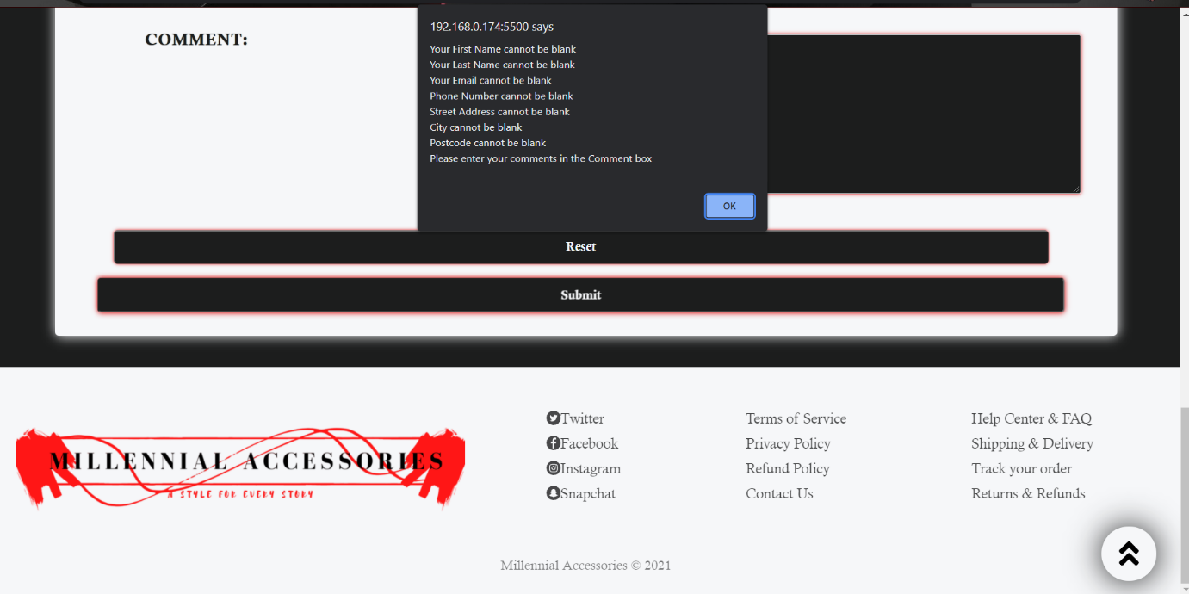

**Form Validation**

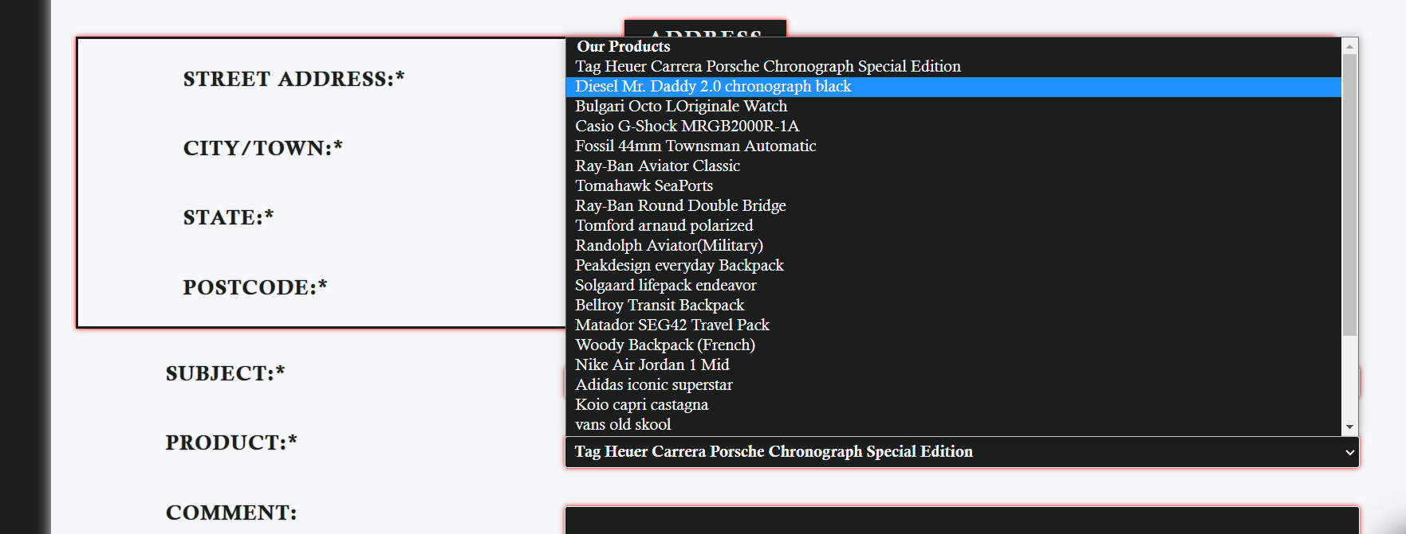

**Populating dropdown list thru arrays**

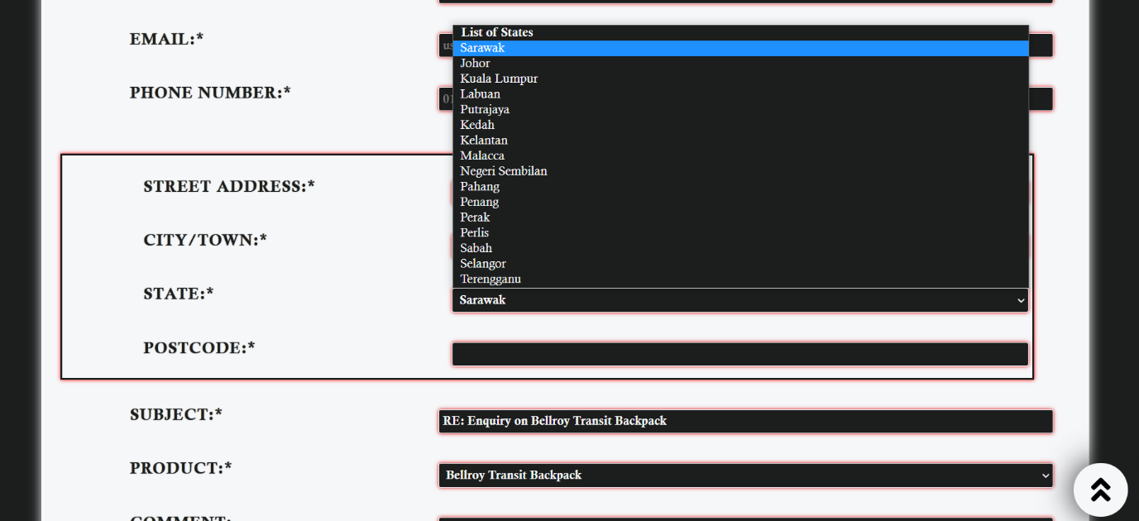

**Transfer Between and withing page and populating dropdown list thru arrays**

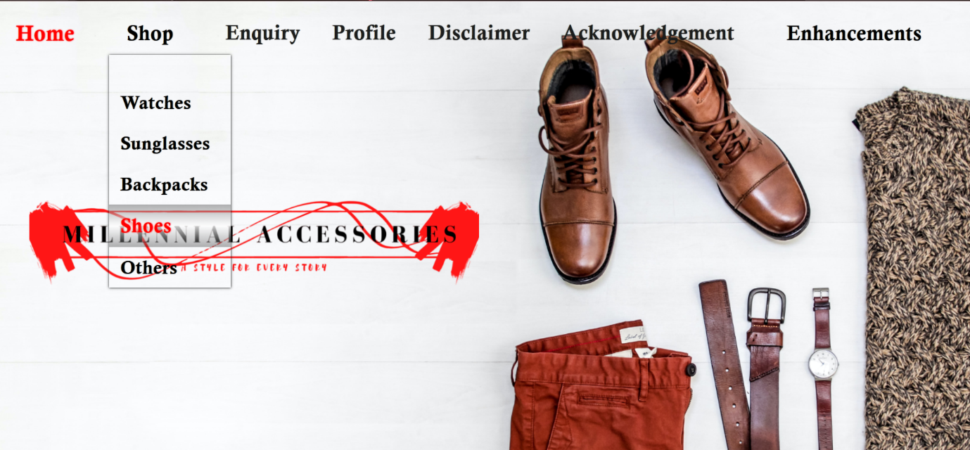

**Populating dropdown menu links thru arrays**

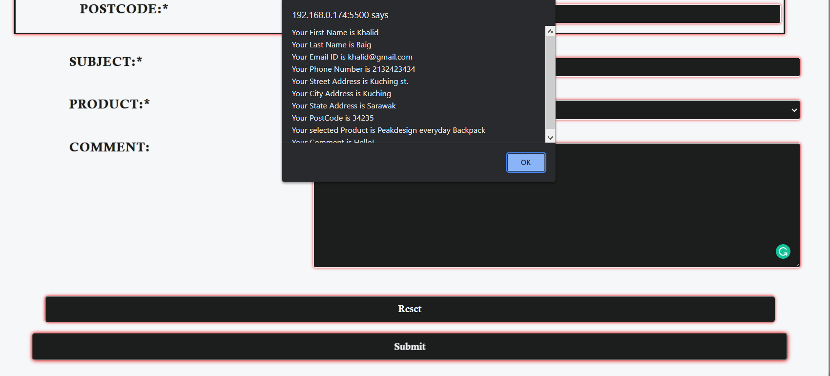

**Alerting User his inputs upon Submission**

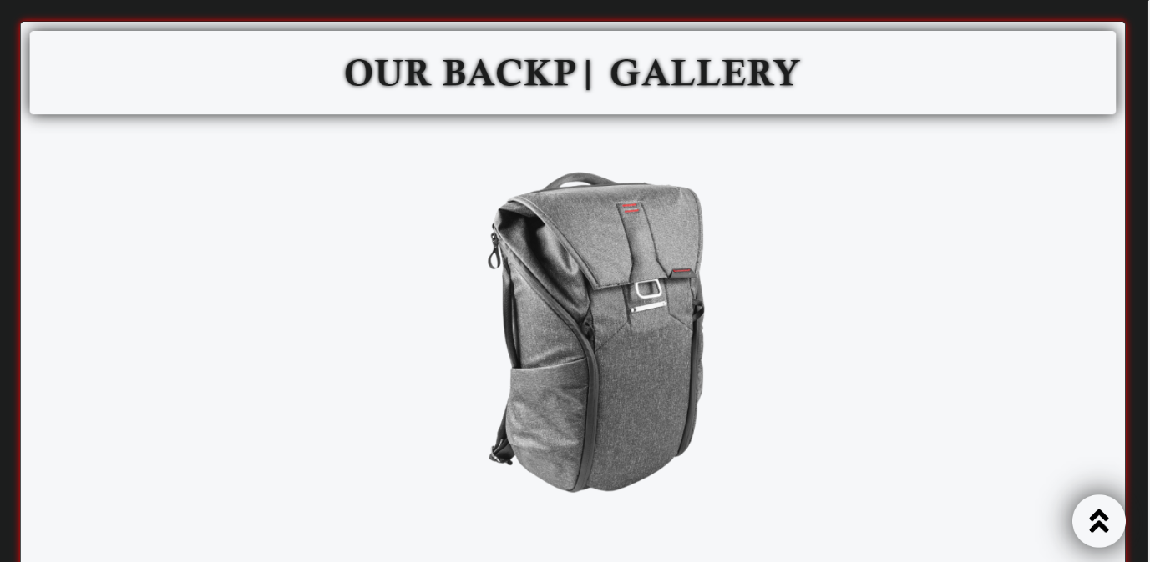

**Automatic Image Slideshow/ back to top button / Infinite typing and deleting effect**

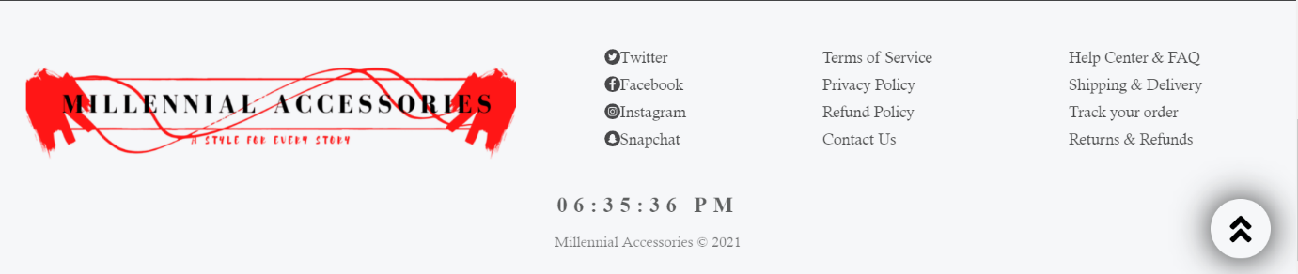

**Real-time 12hr Javascript Clock**

* 1. **Enhancements (if any)**

# **1. Automatic Image Slideshow**

* A web slideshow is a sequence of images or text that consists of showing one element of the sequence in a certain time interval.
* This Java Code is applied by creating a single function which selects the images from the html, and then display all the pics by coverting them from display-none/opacity-0 to display-block.opacity-1 one by one at an interval rate of 3secs.
* [Source](https://youtu.be/o_hRhTZORNY) : <https://www.youtube.com/watch?v=o_hRhTZORNY>
* Enhancement is applied in the Index page for a slideshow of product images.

# **2. Scroll Back To Top Button**

* A page element with relative positioning gives you the control to absolutely position children elements inside of it.
* This Java code is implemented by creating two main function, one for the appearance of the button when user scrolls down and other for going back to top when user clicks the button, which is then applied thru window.onscroll
* [Source](https://www.w3schools.com/howto/howto_js_scroll_to_top.asp) : <https://www.w3schools.com/howto/howto_js_scroll_to_top.asp>
* Enhancement is applied on all the pages of the website

# **3. Pop-up a preview page prior feedback formsubmission**

* This Enhancement alerts back the user his inputs on submition of the form thru a alert window
* This Java Code is applied through alert function
* [Source](https://swinburnesarawak.instructure.com/courses/780/pages/week-6-introduction?module_item_id=37972): <https://swinburnesarawak.instructure.com/courses/780/pages/week-6-introduction?module_item_id=37972>
* Enhancement is applied in the Enquiry page, User will get alerted on his inputs through a alert window upon submission.

# **4. Infinite Typing and Deleting Effect**

* In this Enhancement, a real-time Infinite typing and deleting effect will be added for text
* This Java code is implemented through storing the words required in a string format through a const and then its called under a function which then types it out through looping function at a timing interval of of 550, at the same time the first written string is deleted at a timing interval of 500 under a different function through looping and then the process is repeated infinitely to create an infinite typing and deleting effect.
* [Source](https://codepen.io/haaswill/pen/VKzXvZ): <https://codepen.io/haaswill/pen/VKzXvZ>
* Enhancement is applied at the heading of the automatic slideshow in the index page to describe which product category is currently displayed.

# **5. JavaScript Clock**

* In this Enhancement, a real-time 12hr Clock has been implemented which will inform the user his/her time
* This Java code is implemented through extracting the hours, minutes, and seconds and then its stored in a desired format and then displayed.
* [Source](https://codepen.io/afarrar/pen/JRaEjP): <https://codepen.io/afarrar/pen/JRaEjP>
* Enhancement is applied at the footer of the Index Page

*[Describe the enhancements if any]*

**Assignment 3**

1. **Description**

**1. Reuse Common elements in the website thru PHP**

PHP provides us with techniques to modularise and reuse our web application scripts, the common elements in the website such as the navigation bar, the footer which are static and used in multiple webpages are saved under a php file which is called out whenever required.

**2. Creating a database table for enquiry page**

The enquiry sent by potential customers from the enquiry page form is recorded in a table on a MySQL Databse with the help of PHP and MySQL.

**3. An ‘enquiry_process.php’ page**

Upon submission of the enquiry form in ‘enquiry.php’ web page, the data of the enquiry form is processed by the ‘enquiry_process.php’ page and is stored in the MySQL Table. The user is shown his inputs and a confirmation statement is displayed that his enquiry is record successfully.

**4. A ‘view_enquiries.php’ page**

This page retrieves all the enquiry data from MySQL Databases and displays the data in a table format so the data is properly readable by the user.

*[Provide brief description on how PHP is applied to the website]*

1. **MySQL database structure/schema**

**$sql = "CREATE TABLE Enquiry(**

**ID INT(4) UNSIGNED AUTO_INCREMENT PRIMARY KEY NOT NULL,**

**FIRSTNAME VARCHAR(20) NOT NULL,**

**LASTNAME VARCHAR(20) NOT NULL,**

**EMAIL VARCHAR(30) NOT NULL,**

**PHONE INT(10) NOT NULL,**

**STREET VARCHAR(50) NOT NULL,**

**CITY VARCHAR(30) NOT NULL,**

**STATE VARCHAR(30) NOT NULL,**

**POSTCODE INT(5) NOT NULL,**

**SUBJECT VARCHAR(50) NOT NULL,**

**PRODUCT VARCHAR(30) NOT NULL,**

**COMMENT VARCHAR(500) NOT NULL**

**)";**

*[Prepare a table to show MySQL database used in the website]*

1. **End Product**
   1. **Actual User Interface**



**Navigation menu reused in every page from a php file.**

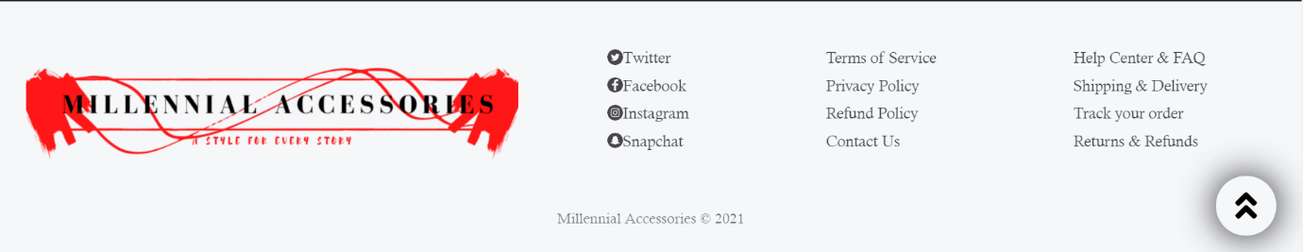

**Footer reused in every page from a php file**

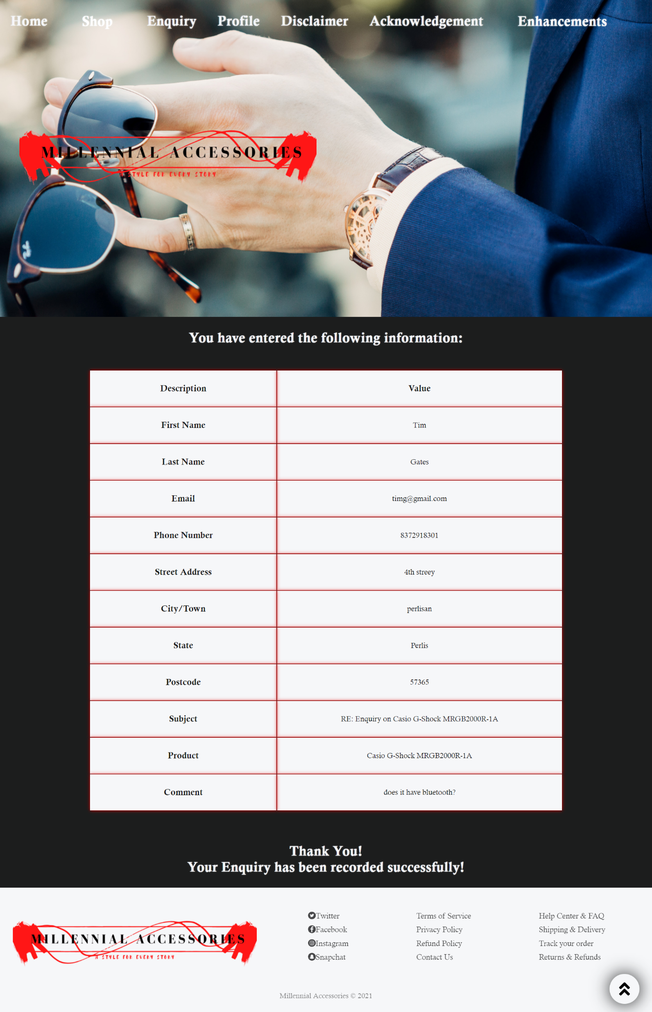

**The ‘enquiry_process.php’ page where the data of the enquiry form is processed and is stored in the MySQL Table. The user is shown his inputs and a confirmation statement is displayed that his enquiry is record successfully**

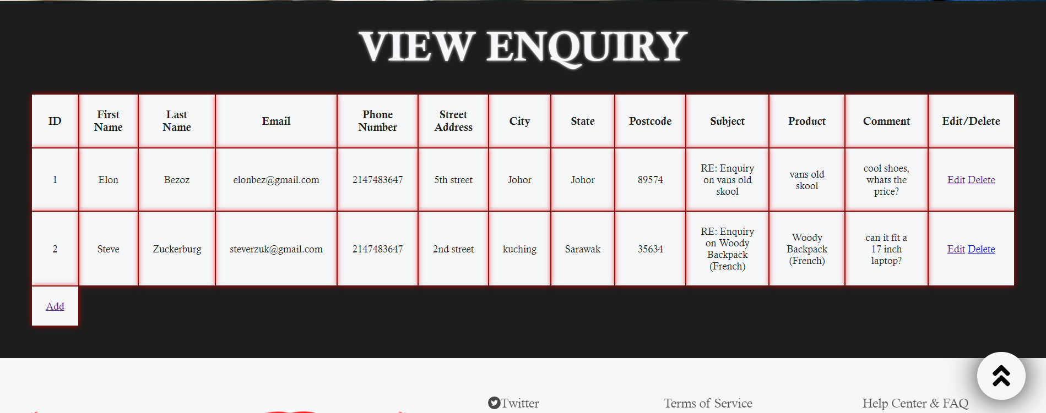

**The ‘view_enquiries.php’ page where the owner is able to access the data submitted by users from the enquiry form through MySQL, the data is displayed in a table format and the owner is able to edit, delete and add data to the table easily.**

* 1. **Enhancements (if any)**

**User Management Module**

* In this Enhancement, the owner is able to create, view, edit and delete data in the view_enquiries page, which is submitted by the users through enquiry form.
* This php code is implemented by creating multiple php files required for the program such as ‘edit.php’, ‘update.php’, ‘delete.php’, ‘createdata.php’ and ‘adddata.php’.
* [Source](https://codepen.io/afarrar/pen/JRaEjP): <https://www.youtube.com/watch?v=mpQts3ezPVg&t=747>s
* Enhancement is applied at the view_enquiries.php

*[Describe the enhancements if any]*